
[Insert your practice logo/details here]

Dear valued patient,
We always endeavour to enable you to have a smile that you are confident of. Here is an opportunity that we are excited to share.
If you have wanted to straighten your teeth, then keep reading.
We all know that the cost of certain medical treatments is sometimes beyond our means and perhaps not in our medical aid cover. The great news is that we now have a payment plan for Active Aligners through MediFin**. This gives you the opportunity to pay for your Active Aligners on a monthly basis.
What are Active Aligners you ask?
Instead of metal wires or brackets, you will be wearing what is often called “invisible” braces. These braces or trays are custom made and are worn in sequence to move your teeth in stages. They work by gradually shifting your teeth into their optimal position, making your teeth straighter.
So how does it work?
- Consult your doctor and get quote
- Gather your documents
- Apply online
- Await approval*
- Payment made
Please use the link to get more details www.activealigners.co.za/finance/
If you have any further questions, please contact us.
We look forward to seeing you start the journey to your best smile.
Kind regards,
[insert your signature/ name]
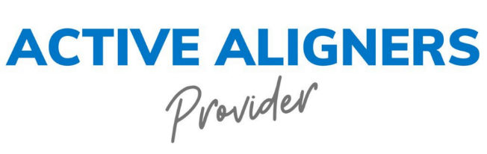

*Ts & Cs Apply ** MediFin Financial Services, a division of Commonwealth Finance South Africa (Pty) Ltd (Reg No 2012/154097/07), is an authorised Financial Services Provider (FSP46701) and Registered Credit Provider (NCRCP8071) MFSA number 7196

